**Documentation for Classification Scenario**

On the dashboard home page, the user selects a classification from the dropdown and a date range (Last 24 hours, Last week, Last month, or a custom range). This action generates a stacked bar chart displaying counts for Submission/Draft, Quoted, and Bound for each classification within the chosen date range.

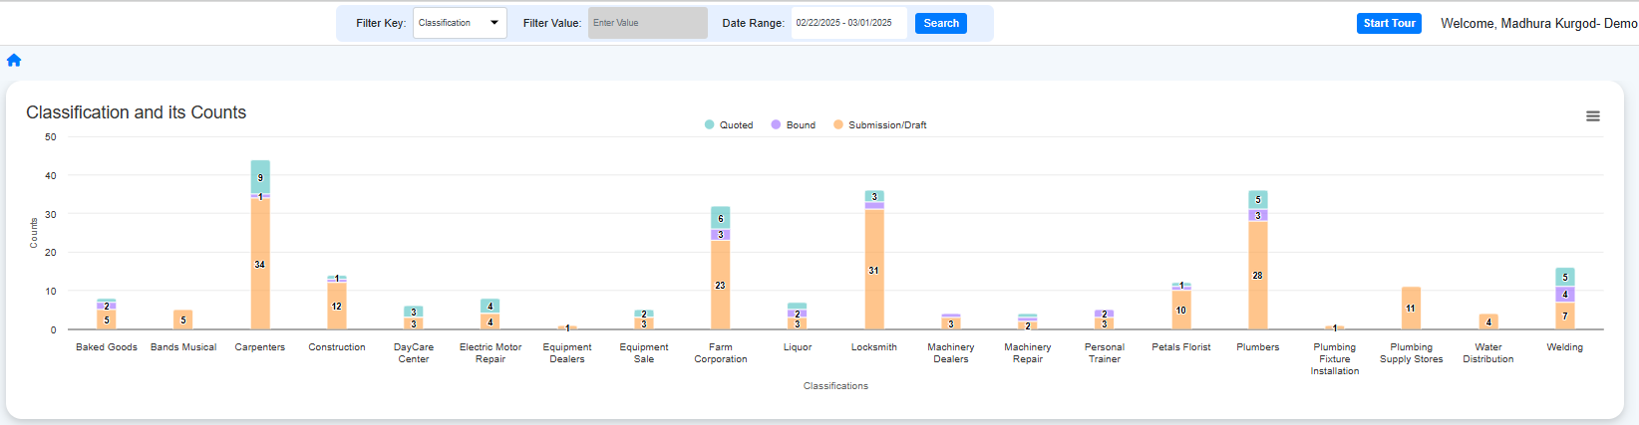

The stacked bar represents quotation numbers in the Submission/Draft, Quoted, or Bound stages.

Clicking on a specific section (for example, Submission/Draft) of the bar chart for Carpenters will display information like Agency Name, Agent Name, Quotation Number, Account Name, Line of Business (LOB), Quote Status, Date/Time, and Session ID for quotation numbers in that status.

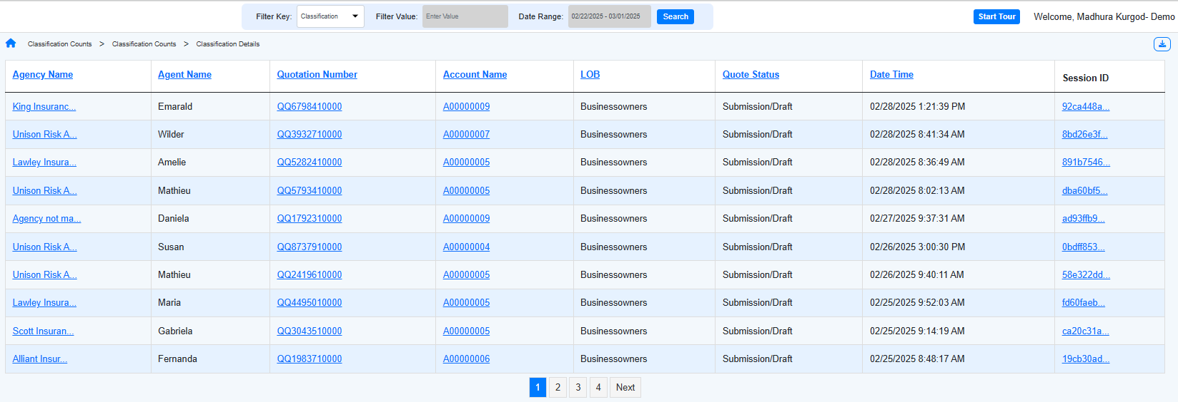

Clicking on a specific section (for example, Quoted) of the bar chart for Carpenters will display information like Agency Name, Agent Name, Quotation Number, Account Name, Line of Business (LOB), Quote Status, Date/Time, and Session ID for quotation numbers in that status.

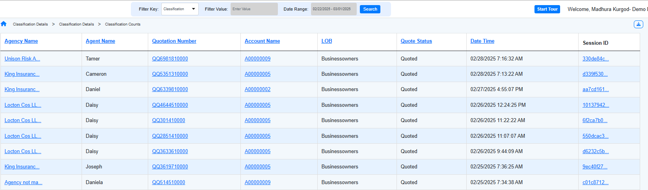

1. How many quotations are currently in the Submission/Draft status for each of the classification?
2. Which classification has the maximum number of bound quotations? / Which classification has the most successful quotations?
3. List the classifications that have more quotations in the Quoted status than in the Bound status.
4. Which classification has quotations only in the Submission/Draft status and not in any other status?
5. Who are the agents handling Submission/Draft quotations in the Construction classification?
6. How can I check the status of my quotation number?
7. List the agents associated with successful quotations for each classification.
8. What errors have agents encountered for their quotations in the Quoted status?
9. Do all quotation numbers in the Quoted status have errors?
10. Show me the agents for successful quotes in each classification.
11. What is the maximum premium recorded for each classification?
12. Are there any quotation numbers in the UW Block? If yes, list them for each classification.
13. Are there any classifications that do not have quotations?
14. When a user clicks on the Submission/Draft, Quoted, or Bound section of the stacked bar chart, what details are displayed?
15. List the quotation numbers for Baked Goods for the last week (/last month/last 24 hours).
16. Generate a bar chart to compare the number of bound quotation numbers in each classification.